Resources:

-FunfFunFunction: https://www.youtube.com/channel/UCO1cgjhGzsSYb1rsB4bFe4Q

-Salesforce Trailhead: <https://trailhead.salesforce.com/users/00550000006yDdKAAU/trailmixes/build-your--developer-career-on-salesforce>

Be more proactive reaching out to people on Linkedin

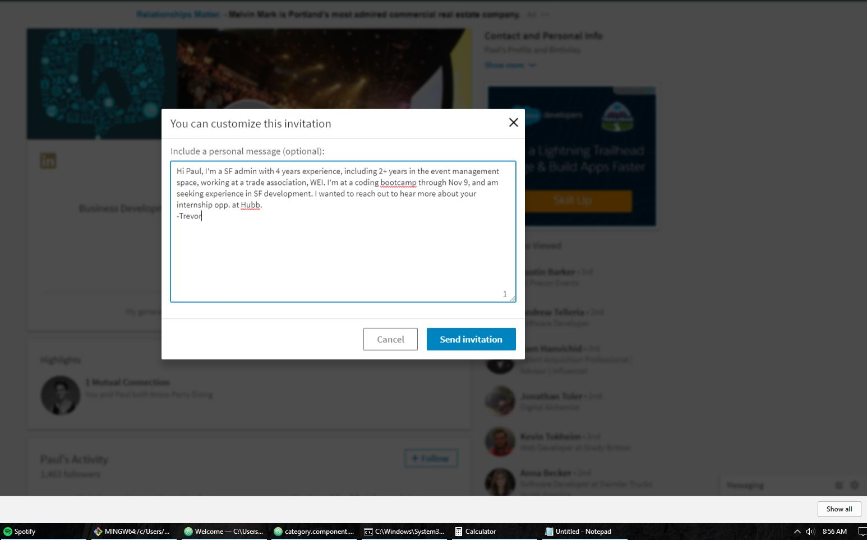

Find the time to attend local events

